Ultimate Valentines Day Experiences at Natadola Bay

Exclusive Unforgettable Experiences

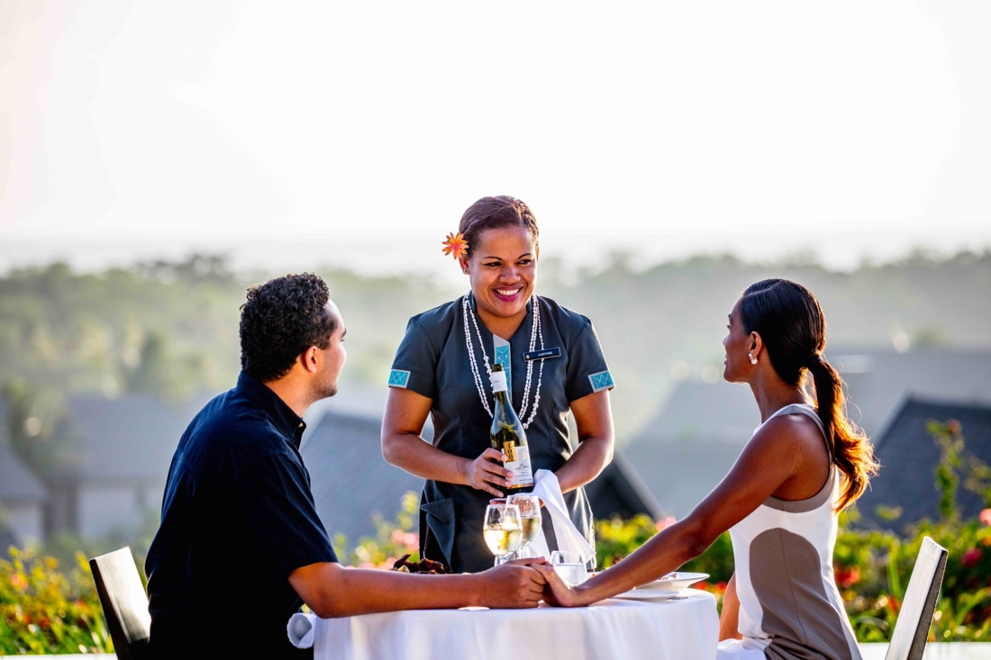

Add a little touch of romance to your stay at InterContinental Fiji Golf Resort & Spa

25 January 2022 (Natadola, Fiji): Valentine’s Day is a celebration of romance for couples, young and old, around the world. Create unique romantic moments that will last forever this Valentine’s Day with InterContinental Fiji Golf Resort & Spa’s as we share our top insider tips and exquisitely curated experiences.

Here are our top five exclusive romance experiences at the award-winning Natadola Bay.

Queen Cleopatra's Essence of Love Bathing Ritual
Indulge in a milk bath drawn by bath butlers and infused with aromatherapy blends and set up with floating tropical petals. Your bathing ritual is a blend of locally harvested coconut oil, fresh coconut milk infused with vanilla and pure honey. This is offered as a night experience and is complemented with the candles. Sparkling Wine or Champagne is also on offer with this experience.

Couples Cabana Massage
Surrender yourself to a tropical beachside cabana experience for an immersive experience filled with positive vibes and complete rejuvenation. Drift away to the natural rhythm of waves crashing along the shores and gentle fresh breeze. Allow your senses to discover exotic, tropical fragrances of Pure Fiji products that allow your mind and body to be reawakened, replenished, and nourished.

Visit here for more information or for reservations.

Love Pod Afternoon Tea
Exclusive to the ultra-exclusive Club InterContinental and perched hilltop are love pods that frame the pool and offer some amazing views of the Pacific Ocean. Enjoy an afternoon at leisure curled up in one of our love pods and await the Club Butlers to deliver a sumptuous 3-tiered high tea. Add to the experience with a bottle of champagne on ice and surrender to a blissful day of romantic leisure.

Learn more here.

Jet Ski Safari
Book a jet ski safari with our in-house Hydro Water Sports team and set off on a romantic adventure. Explore the blue waters of Natadola Bay and an enjoy an exhilarating 3-hour tour inclusive of a sand bar picnic. This adrenaline-packed adventure combines jet skiing with spectacular scenic views of the majestic Natadola Bay.

Bespoke Dining Experiences
Enjoy a private and exclusive dining experience that offers a sample of the bespoke menu options that the Resort has on offer. You can choose from a Private Cabana Dinner or Dinner Under the Stars for an outdoors exclusive experience. We also have an offer the Private Dining Room located within our award winning Navo Restaurant with its backdrop of old and new world wines for an in-door experience.

Framed by the rolling green hills of Natadola Bay and the cerulean blue waters of the Pacific Ocean, InterContinental Fiji Golf Resort and Spa with its many experiences offers the perfect backdrop for a romantic escape in Paradise.

ENDS

Images to download: CLICK HERE

Media Contact
[Krishnil Prasad, +679 673 3300 +679 998 2641]
[Krishnil.Prasad@ihg.com]

Notes to Editors

About the InterContinental Fiji Resort and Spa: The only luxury resort on beautiful Natadola Bay, InterContinental Fiji Golf Resort & Spa is designed to treat guests to an exclusive outer island experience on the main land. Spread across 35 acres of tropical manicured landscapes, the resort offers the facilities and services expected of a luxury international resort, including a luxury spa, three pools, a dive pool, an on-site dive centre, three restaurants & two bars, recreation and beach activities centre, volleyball, gym, and fitness centre and 18-hole championship golf course.

About InterContinental® Hotels & Resorts: The InterContinental® Hotels & Resorts brand makes travel alluring, with insights from 75 years of experience. Each of our properties provides a gateway to the glamour of the InterContinental Life. As a brand, we aim to embody global sophistication through our superior, understated service and exceptional amenities. What makes us uniquely different is the genuine interest we show our guests through personalised and attentive services. We offer our most valued guests signature VIP services through a dedicated InterContinental® Ambassador programme and an exclusive Club InterContinental® experience. We connect our well-travelled guests to what is special about a destination, so they enjoy authentic local experiences that will enrich their lives. For more information and to book, visit www.intercontinental.com, and connect with us on Facebook www.facebook.com/intercontinental and Instagram www.instagram.com/intercontinental.

About IHG Hotels & Resorts:
IHG Hotels & Resorts [LON:IHG, NYSE:IHG (ADRs)] is a global hospitality company, with a purpose to provide True Hospitality for Good. With a family of 16 hotel brands and IHG Rewards, one of the world’s largest hotel loyalty programmes, IHG has 6,000 open hotels in more than 100 countries, and a further 1,800 due to open over the next five years.
- Luxury and lifestyle: Six Senses Hotels Resorts Spas, Regent Hotels & Resorts, InterContinental Hotels & Resorts, Kimpton Hotels & Restaurants, Hotel Indigo
- Premium: HUALUXE Hotels & Resorts, Crowne Plaza Hotels & Resorts, EVEN Hotels, voco Hotels
- Essentials: Holiday Inn Hotels & Resorts, Holiday Inn Express, avid hotels
- Suites: Atwell Suites, Staybridge Suites, Holiday Inn Club Vacations, Candlewood Suites
InterContinental Hotels Group PLC is the Group’s holding company and is incorporated in Great Britain and registered in England and Wales. Approximately 350,000 people work across IHG’s hotels and corporate offices globally. Visit us online for more about our hotels and reservations and IHG Rewards. For our latest news, visit our Newsroom and follow us on LinkedIn, Facebook, and Twitter.

