InterContinental Fiji Invests into Meeting & Event Spaces and Pure Air Technology
ActivePure Technology Now In Place & Proven to Reduce Over 99.9% of the Virus That Causes COVID-19, both On Surfaces and In the Air

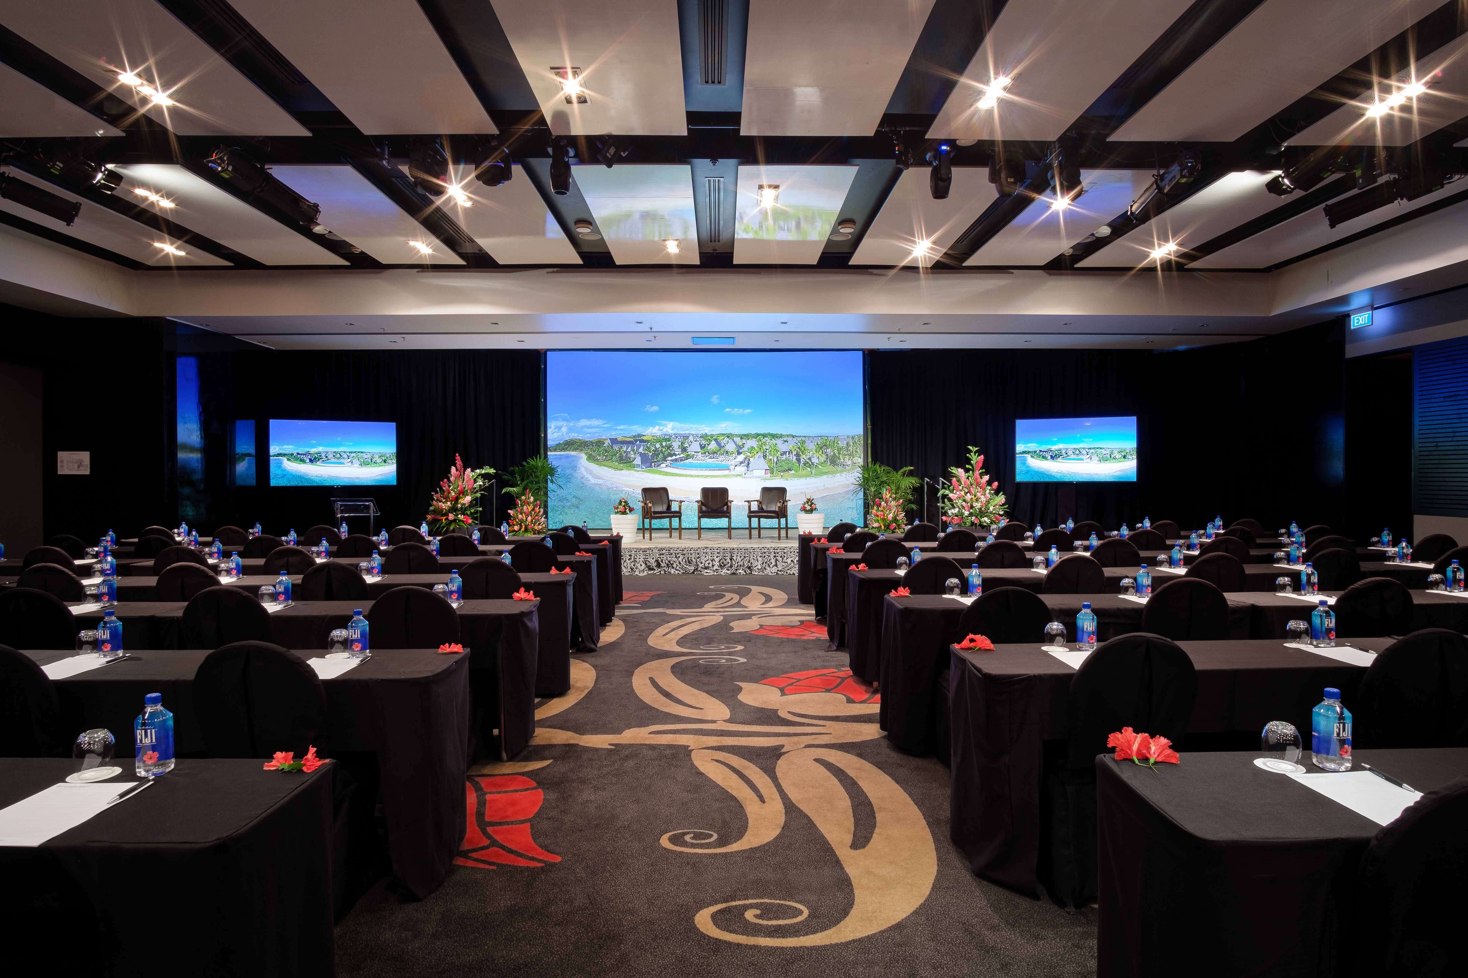

The InterContinental Fiji Golf Resort & Spa has a new air filtration system in place.

21 January 2022 (Natadola, Fiji): InterContinental Fiji Golf Resort & Spa, located at award winning Natadola Bay is set to lead the way for Fiji's events and conferencing experience with timely investments made into audio and visual services, air conditioning, air filtration and an electrostatic spraying unit for a safer, cleaner, and hygienic experience for events and conferencing delegates.

Encore Events Technologies, the in-house service provider for audio and visual services has just completed a quarter million-dollar upgrade that is set to positively impact the overall event experience at Natadola Bay. Part of the upgrades include new wider 4K projectors and drop-down screens in its meeting rooms that enables a much larger viewing surface, upgraded 75-inch TV screens, digital concierge systems for meeting facilitators and event planners as well as rewiring of event spaces for a better audio experience. Together with this, state of the art Video over IP (VoIP) system has been installed to distribute vision throughout the space, installed wireless access points allow vision routing through handheld smart devices. This is further complemented with the twenty-four ceiling speakers enabling even distribution of premium surround sound across the space. A WiFi controlled audio mixer has also been added that allows for wireless access to each of the rooms audio controls. These upgrades have also allowed Natadola Bay to be a more suitable venue of choice for hybrid events that need digital connection with multiple venues in other parts of the World at any one given time. Guests are seamlessly able to remotely attend meetings, share screens and content with ease supported by high-speed WiFi.

With serious concerns, in the wake of COVID, for delegates health and wellbeing at events, the Resort has further invested in ActivePure Technology that enhances air filtration in the Resort's pillarless and freestanding Ballroom. ActivePure's Proactive Pathogen Defense™ creates oxidizing molecules that significantly reduces viruses, bacteria, odors, and volatile organic compounds - both on surfaces and in the air. The biodefense air purification system has been used in NASA (National Aeronautics and Space Administration) spaceships and space stations for number of years and has received the prestigious award of being inducted into the Space Hall of Fame in 2017 and is one of only 75 technologies to receive such an honour in 30 years.

Ensuring that enabling the personal wellbeing of guests and colleagues is key, the property has also implemented using hospital-grade disinfectants and electrostatic technology. The Peroxide Multi Surface Cleaner and Disinfectant is Australia Therapeutic Goods Administration (TGA) listed which has been proven to kill bacteria, viruses, and fungi. Electrostatic spray (ESS) is electrically charged, allowing the appropriate sanitizers and disinfectants to wrap around and evenly coat all types of surfaces for a more complete clean. As the chemical exits the electrostatic sprayer, it is given a positive electrical charge. The droplets then become attracted to all negative surfaces, covering the visible area, underside, and backside, with the sanitizing agent.

Lachlan Walker, Area General – South Pacific, InterContinental Hotels Group said: “The safety and well-being of our guests and colleagues is paramount to the True Hospitality we deliver at the Resort each day – and we understand that the priority on cleanliness is more important now than ever as consumer confidence on travel is gradually building. Globally throughout the response to the pandemic, IHG (InterContinental Hotel Group) has built on an already strong heritage of cleanliness and hygiene by implementing a variety of enhanced processes based on the guidance of health authorities and industry-leading experts and exploring where technology can make a difference. We are always exploring ways to offer guests, colleagues and visitors even further confidence in a safe, comfortable hotel experience.”

The award-winning InterContinental Fiji Meetings, Incentives, Conferences and Events are designed to capture a genuine sense of place that will inspire delegates and get results. The Resorts location is enhanced by two kilometres of white sandy beach and the beautiful South Pacific waters beyond that provide the perfect backdrop for any event of conference.

To learn more about the meeting spaces, email meetings.fiji@ihg.com, phone +679 673 0000 or visit https://www.fiji.intercontinental.com/meetings-events

ENDS

Images to download: CLICK HERE

Media Contact
[Krishnil Prasad, +679 673 3300 +679 998 2641]
[Krishnil.Prasad@ihg.com]

Notes to Editors

About the InterContinental Fiji Resort and Spa: The only luxury resort on beautiful Natadola Bay, InterContinental Fiji Golf Resort & Spa is designed to treat guests to an exclusive outer island experience on the main land. Spread across 35 acres of tropical manicured landscapes, the resort offers the facilities and services expected of a luxury international resort, including a luxury spa, three pools, a dive pool, an on-site dive centre, three restaurants & two bars, recreation and beach activities centre, volleyball, gym, and fitness centre and 18-hole championship golf course.

About InterContinental® Hotels & Resorts: The InterContinental® Hotels & Resorts brand makes travel alluring, with insights from 75 years of experience. Each of our properties provides a gateway to the glamour of the InterContinental Life. As a brand, we aim to embody global sophistication through our superior, understated service and exceptional amenities. What makes us uniquely different is the genuine interest we show our guests through personalised and attentive services. We offer our most valued guests signature VIP services through a dedicated InterContinental® Ambassador programme and an exclusive Club InterContinental® experience. We connect our well-travelled guests to what is special about a destination, so they enjoy authentic local experiences that will enrich their lives. For more information and to book, visit www.intercontinental.com, and connect with us on Facebook www.facebook.com/intercontinental and Instagram www.instagram.com/intercontinental.

About IHG Hotels & Resorts:
IHG Hotels & Resorts [LON:IHG, NYSE:IHG (ADRs)] is a global hospitality company, with a purpose to provide True Hospitality for Good. With a family of 16 hotel brands and IHG Rewards, one of the world’s largest hotel loyalty programmes, IHG has 6,000 open hotels in more than 100 countries, and a further 1,800 due to open over the next five years.
- Luxury and lifestyle: Six Senses Hotels Resorts Spas, Regent Hotels & Resorts, InterContinental Hotels & Resorts, Kimpton Hotels & Restaurants, Hotel Indigo
- Premium: HUALUXE Hotels & Resorts, Crowne Plaza Hotels & Resorts, EVEN Hotels, voco Hotels
- Essentials: Holiday Inn Hotels & Resorts, Holiday Inn Express, avid hotels
- Suites: Atwell Suites, Staybridge Suites, Holiday Inn Club Vacations, Candlewood Suites
InterContinental Hotels Group PLC is the Group’s holding company and is incorporated in Great Britain and registered in England and Wales. Approximately 350,000 people work across IHG’s hotels and corporate offices globally. Visit us online for more about our hotels and reservations and IHG Rewards. For our latest news, visit our Newsroom and follow us on LinkedIn, Facebook, and Twitter.

